**Implementing Web Application**

|  |  |
| --- | --- |
| Name | S.Sangeetha |
| Roll no | **312419104119** |
| Team ID | PNT2022TMID28174 |
| Project Name | Inventory Management System for Retailers |

# TASK

* **Create UI to interact with application**

* + Registration Page
  + Login Page
  + Display items in the Dashboard
  + Adding items
  + Test it

* **Create IBM DB2 and connect with Node.js**

**Create UI to interact with application**

## Registration Page

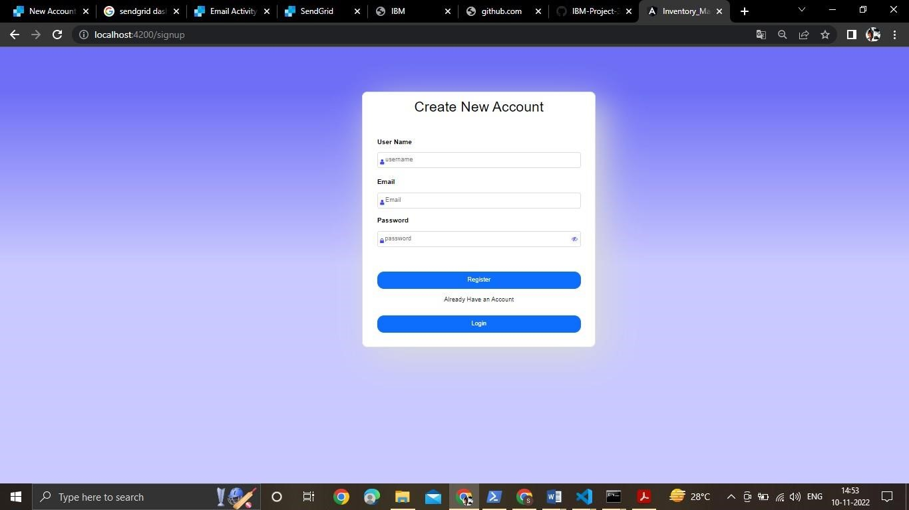

## Login Page

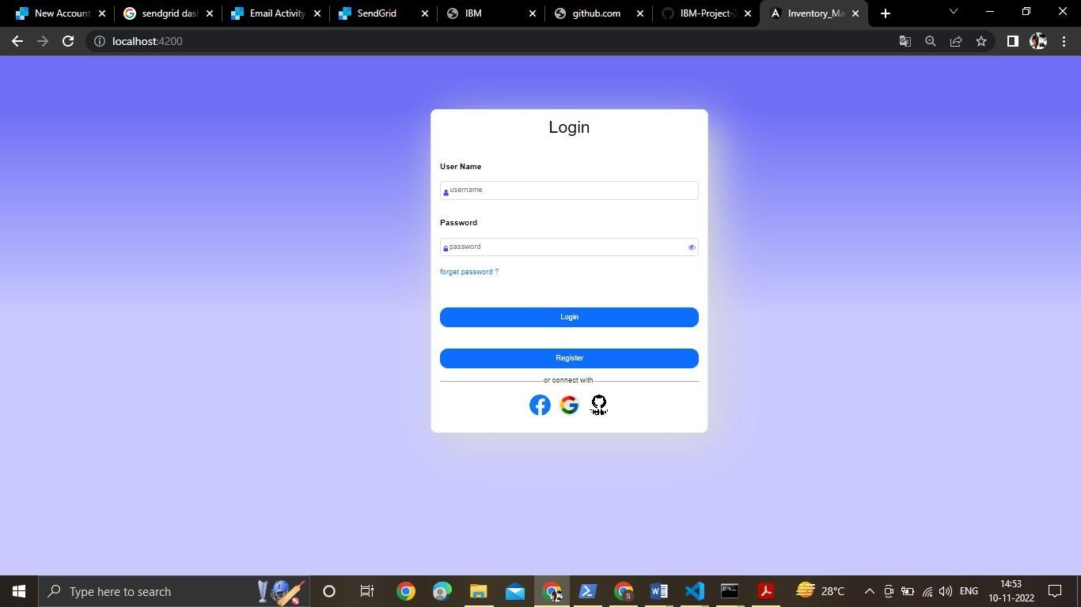

## Display items in the Dashboard

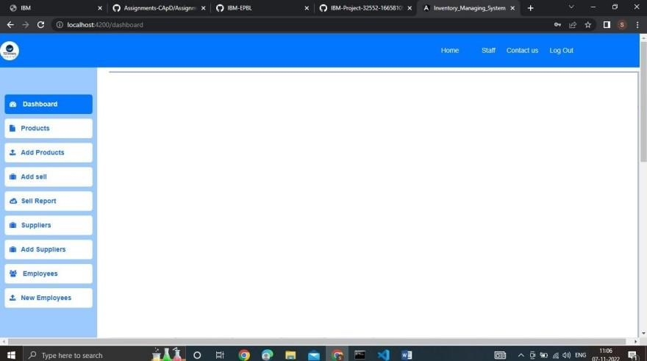

## Adding items

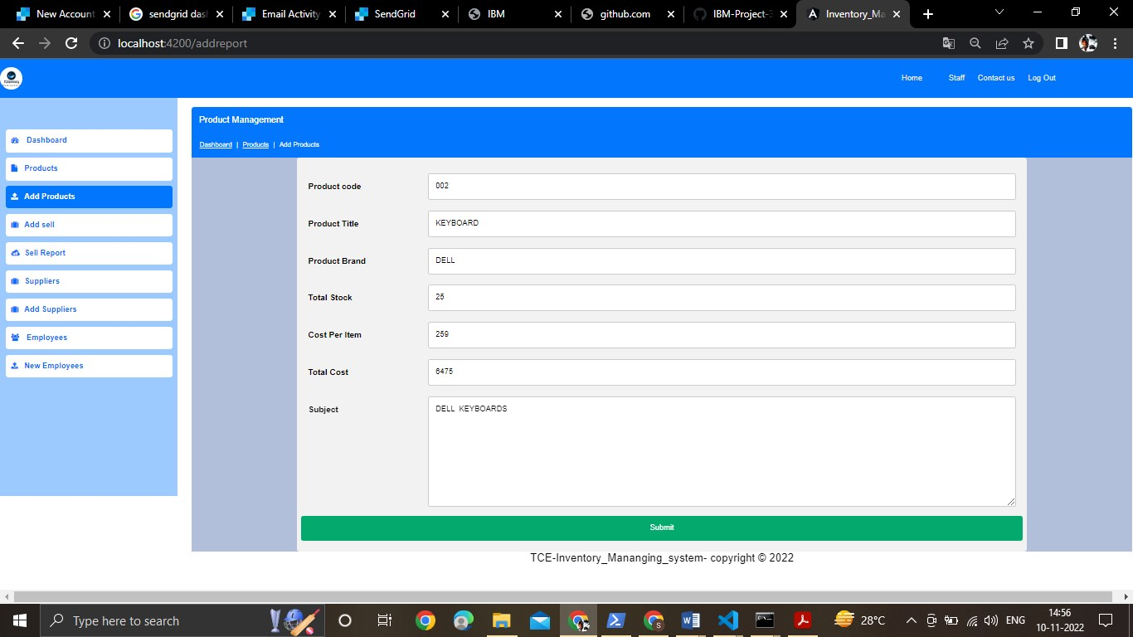

## Test it

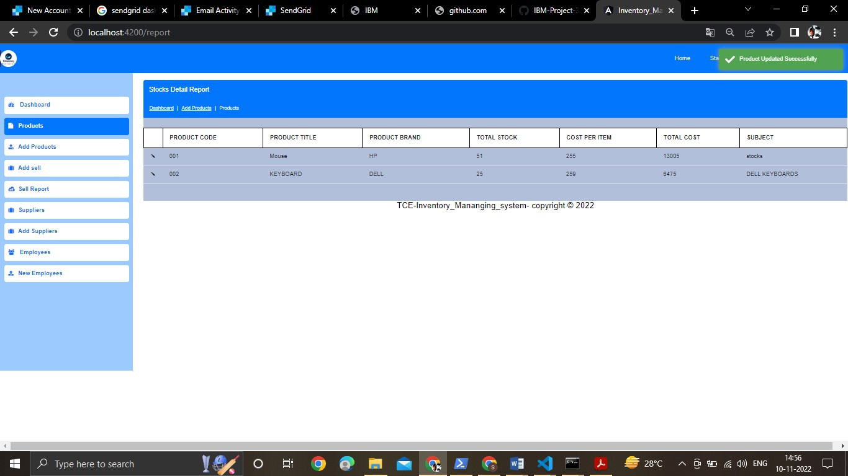

➢ **Create IBM DB2 and connect with Node.js**

